­­

Using Personalized Information Links with analyses that are scheduled into memory for performance considerations requires a User Access Rules table to read added to the application in addition to the activity tables supporting the visualizations & analysis.

* All activity tables will be loaded in their entirety when the scheduled update occurs.
* User Access Rules table will be set to load dynamically when the application is opened (direct read from data source, NOT from memory. This allows only rows with access rules for the %CURRENT_USER% to be retrieved.

The process assumes the use of Information Links to retrieve data from a data source such as SQL server or Oracle, since the solution is designed for optimal retrieval of large volumes of data.

Process outline and detailed steps to create the User Access Rules table and configure the table relationships to limit the data presented to the user are as follows:

**Process Overview**

1. Build a User Access Rules table
2. Create Information Link for User Access Rules table
3. Add Filter element to Information Link for User Access Rule table (to filter by user)
4. Add User Access Rules table to analysis
5. Establish table relationship(s) between User Access Rules table and activity tables to be limited by user
6. For each filter scheme in use, open the filter panel and change the related table filter setting to be limited by user to Include Filtered Rows Only. Repeat or each table that is to be limited by user
7. In data table properties, select the User Access Rules table, go to Scheduled Updates tab, and modify the setting by checking the box to enable reload of data for each user during scheduled updates
8. Schedule the analysis to load into memory as appropriate

**Detailed Instructions**

1. Build a User Access Rules table
   1. User Access Rules table will use a case-specific design that includes one record per user per value of the data column(s) to be used to control access. A simple design example is listed below. The basic requirements are:
      1. The User Name / User ID listed must match the user account when signing into the viewer / web player
      2. The Values in the data column must match the values in the activity table to be limited by user.
      3. If there is no match for User or Value(s), no data will be returned.
      4. If building the User Access Rules table in Business Insight, you will need a column counter for the subset.
      5. Unlike Business Insight Distribution Lists, if an Admin user has unlimited access to all values, the rules must be built for ALL values that user must access,  
           
         
2. Create Information Link for User Access Rules table
   1. The table must be stored in a data table that can be referenced by an Information Link. This is necessary because a filter element must be applied to the Information Link to identify the record(s) that pertain to the current user opening the analysis.

1. Add Filter element to Information Link for User Access Rules table (to filter by user)
   1. In Information Designer, go to the Start tab and under the list of Elements, click Filter

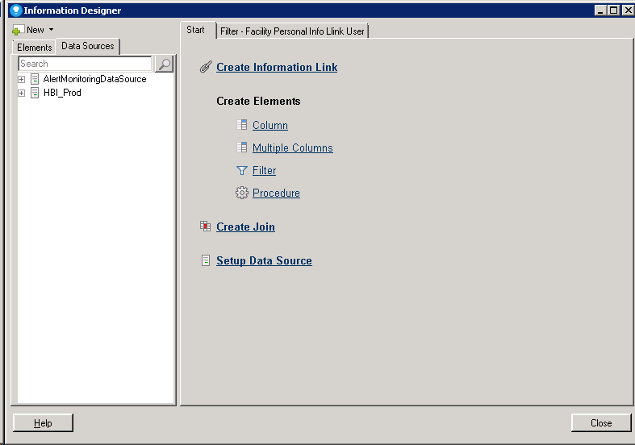

* 1. Navigate to the source database object (database table, SQL view) for the User Access Rules table and select the column that contains the User Name / ID and add it to the Filter Element
  2. In the Expression box, enter the following exactly as seen in the image below:  
     %1 in (%CURRENT_USER%)

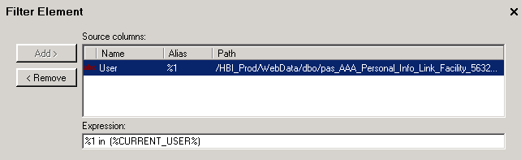

This filter activates when the data is accessed and performs a lookup against the User Access Rules table and returns ONLY the rows that match the User ID / Name

* 1. Add Filter element to the Information Link for your User Access Rules table. To do this, first open the Information Link for your User Access Rules table. Then in the Elements panel on the left, navigate to the folder where your new Filter element is saved. Click on the filter element once to select it. Then in the Information Link click Add> to include the Filter Element in the Information Link. Then Save the Information Link.  
       
     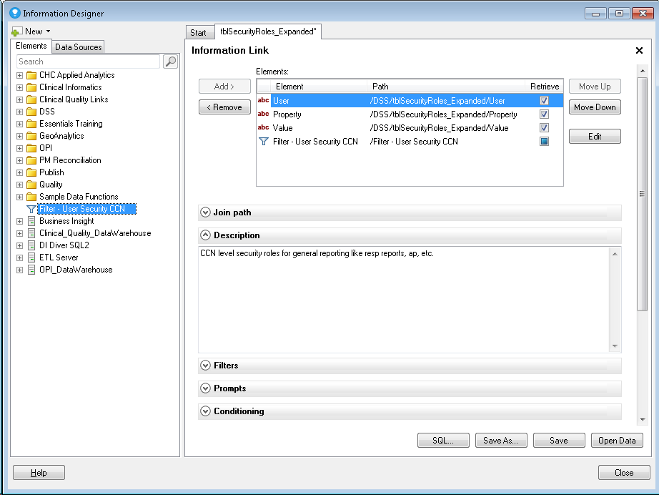

1. Add User Access Rules table to analysis (and any related activity tables not already included)
2. Establish table relationship(s) between User Access Rules table and activity tables to be limited by user
   1. The relationship will generally be based on the column from each table that contains the values the User can access (e.g. Facility, Department)
3. For each filter scheme in use, open the filter panel and change the related table filter setting to be limited by user to Include Filtered Rows Only. Repeat or each table that is to be limited by user.
   1. Left click on the related table icon next to the table name(s)  
        
      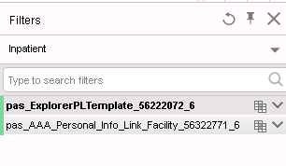
   2. Click filtering in (table name) and check Include Filtered Rows Only  
        
      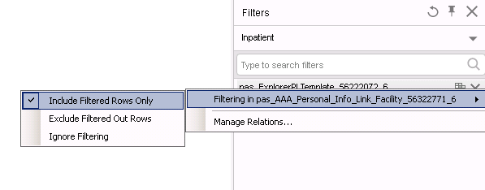
   3. Repeat for each table to be limited by user once for reach filter scheme in use
4. In data table properties, select the User Access Rules table, go to Scheduled Updates tab, and modify the setting by checking the box to enable reload of data for each user during scheduled updates.
   1. This is key to ensure that each user reads their own set of access rules when the analysis is opened
   2. When the analysis is scheduled into memory, this forces the User Access Rules table to reload for each user independently at the time the user selects the analysis in the Viewer / Web Player  
        
      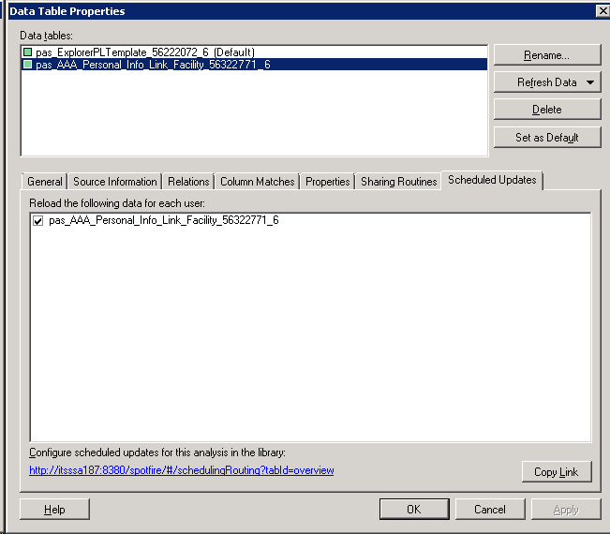
5. Schedule the analysis to load into memory as appropriate